**2/22/2022**

**Christian Alberto Gomez**

**Programming Languages**

**PHP Assignment report**

**URL**

<https://cssrvlab01.utep.edu/Classes/cs3360%20Dr.%20Ward/cagomez15/supermarket.php>

**Features**

Open section:



-The "fruit" and "vegetable" buttons will be displayed when entering the page. The user will have the option to choose one of these two. When the user clicks on one of them, the program will display a table with all the products in that category and some additional buttons. Here is an example of each:

* Find buttons:



-The "find" button will be responsible for displaying the table of contents of the type of product desired by the user. In this case let's say we are in the fruit section and the user wants to find "Apple". Once the user enters the product in the text box and clicks the "Enter" button then the program will display a message saying if the product is available and an image of the product. As an extra, the "Enter" button is used to submit a user's input and have the program execute certain methods depending on the input. Here is an example:

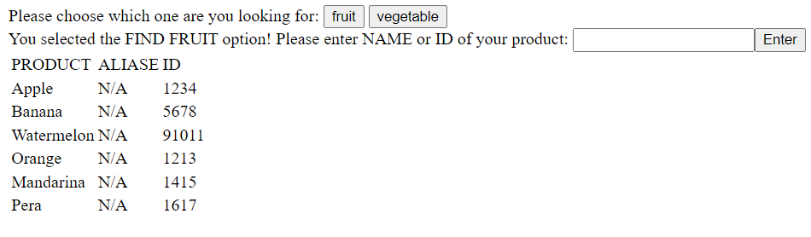



* Add buttons:



-The "add" button will display a text box where the user will have to enter a password (this is because only the manager can do this). In this case the password is **1998**. After the key, the program will display a text box where the user will have to enter the new desired product. Once the user has placed the new product and clicked on the "enter" button, the program will generate a new table with the new product added by the user. Here is an example:

* Edit buttons:



-The "edit" button will take care of adding an alias to the product. This means that a product will have an extra name associated with it so that a user can find it by means of two names. In this case we can say "Apple" and its alias is "Manzana". Once the user clicks on the "edit" button, the program will display two text boxes. The first box will be to enter the product to which you want to add an alias and the second box will be to enter the alias of the already selected product. Once this is executed, the program will display a new table with the product and its alias, both having the same ID(PLU). Here is an example:

**Properties that caused problems**

* "Associative Array" type variables are somewhat complicated to use and update. Many times when I tried to add and/or edit a product, it led me to problems with syntax errors or even that the arrays I was trying to use did not exist.
* A very big problem that I had and something with which I did not feel at all comfortable using PHP is that it is a very inflexible language. How to create different structures can be a very annoying and tedious task. An example is trying to display messages and text boxes once the user clicks a certain button. At first I tried to use if($_POST['something']) inside another if($_POST['anything']). This creates a TRUE and FALSE problem between both if-statements since neither can be true or false. If one if is true then the other if will be false, this will make your buttons not work the right way.

**Structure of the program using a Diagram**

